**Steps:**

* Login to LAGOV
* Click Data Warehouse Tab
* Click Launch Pad (INFO VIEW)
* Click the folder tab on the left of screen
* Click public (left of screen)
* Click LAGOV (Left of screen)
* Click Agency (Middle of screen)
* Click DOTD (middle of screen)
* Click Create by DOTD (middle of screen)
* Click Engineer PO Overview (middle of screen)
* Click Purchase order overview (middle of screen double click)

This will bring up invoice/amounts in LAGOV.

Make sure you are view under the input controls tab see example locate at the top left of screen.  Third block down.

Your search option are endless (search by PO#, H#, project name, etc.).

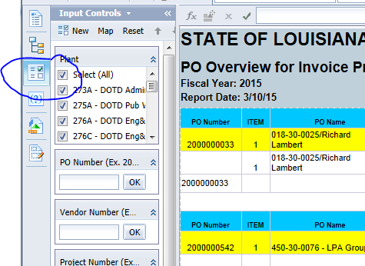

**Setting Preferences so you do not have to drill down:**

See example below.  Click on preferences this is located at the top right hand corner of screen.

cid:image002.png@01D06088.7E802350

* Click folders
* Select public then browse
* Click engineer PO overview
* Save
* Then save and close
* Close out of the program.  Go back into data warehouse follow instruction above.  After you click Launchpad information you should see your preference folder PO OVERVIEW ENGINEERING INVOICE.